1.

1. Retrieve first 2 and last rows using python program
2. Write a command to find most expensive player
3. Write a command to print total players per team.
4. Write a command to find player who had highest bid price from each team.
5. Write a command to find average runs of each team.
6. Write a command to sort all players according to BidPrice.

2.Consider the two arrays

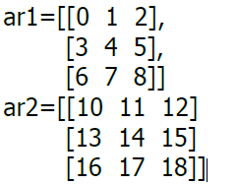

1. Write a command to concatenate ar1 and ar2 a)rowwise and b)columnwise
2. What be the resultant array if the following statement is given?

3. Write a python statement to create one-dimensional array using arange() function. Elements will be range of 10 to 40 with step of 4.Resahape this one dimensional array to two- dimensional array of shape (2,3).Then display only those elements of this two dimensional array which are divisible by 5.

4.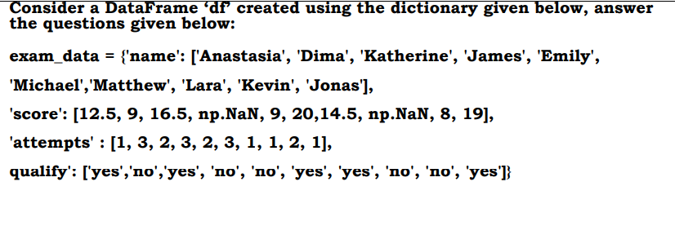

* + Write a command to remove the rows having NaN values.
  + Write a command to display the names of students who have qualified.
  + Write a commands to create pivot table based on ‘qualify’ column and display sum of the score and attempt columns.

5. Consider the following dataframe

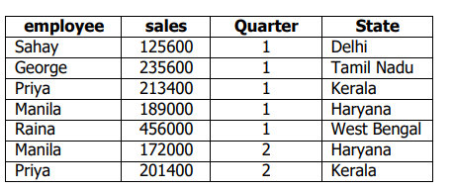

Write a python program to create the above dataframe.